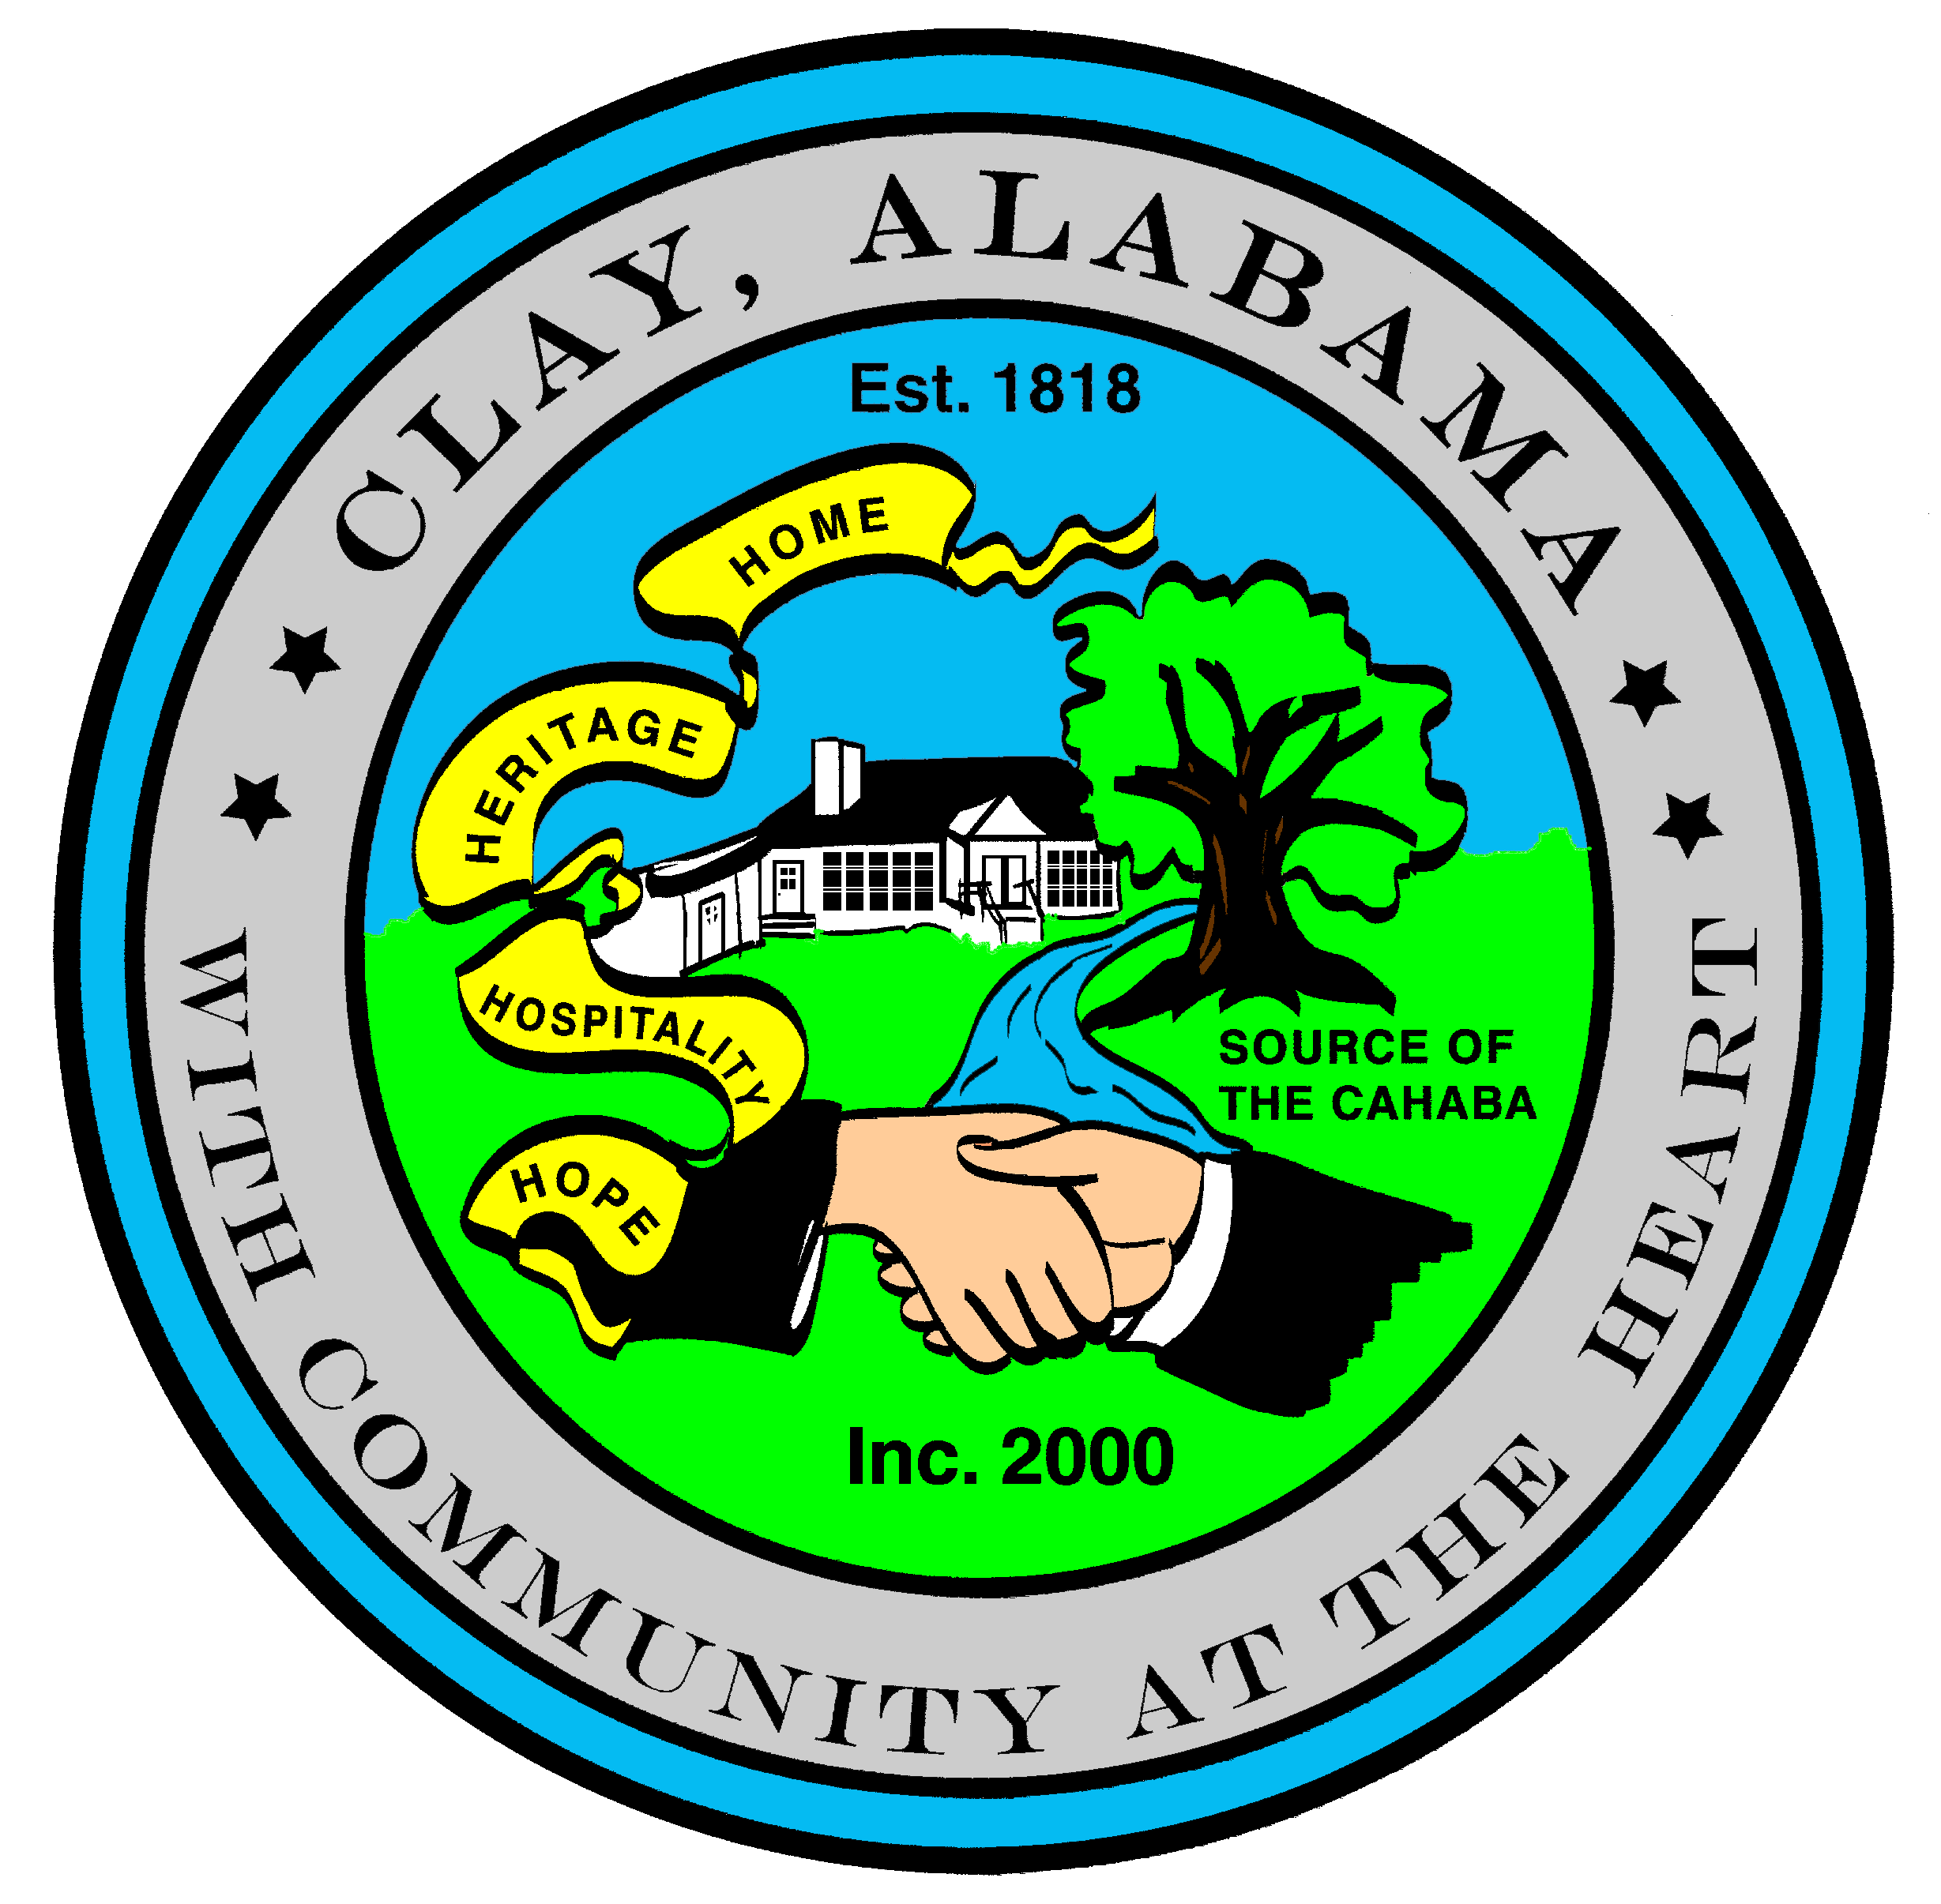
City of Clay
P.O. Box 345
Clay, AL 35048-0345
www.clayalabama.org

AGENDA
CITY COUNCIL MEETING
March 21, 2016
- Call to Order

- Prayer

- Pledge to the Flag

- Roll Call

- Approval of minutes
Pre-Council and Regular Council Minutes: March 7, 2016
- Approve Agendas
Approve Meeting Agenda
Approve Consent Agenda (Financial)

- Mayor and Council Comments
  - Mayor Webster
  - Councilor Baker
  - Councilor Becky Johnson
  - Councilor Bo Johnson
  - Councilor Small
  - Councilor Thackerson
Candi McEvoy

- Reading of Petitions, Applications, Complaints, Appeals, Communications, etc.

- City Manager’s Report/Auditing Accounts
- Public Hearings
Z-2016-03, 5594 Old Springville Road/4333 Paradise Lane/4336 Paradise Lane
ALC-2016-01, Circle K
- Resolutions, Ordinances, Orders, and other business
Enter Into Unanimous Consent:
Resolution 2016-10 Allow the Mayor to Enter Into a Contract with Jefferson County for Election Equipment
End Unanimous Consent
- Public Comments
- Adjourn
Next City Council Meeting – Monday, April 4, 2016, 6:30 pm.

(Pre-Council meeting: Presentation by Total Cost Advocates, Sherri Hood)

